YEAR 12 GENERAL HUMAN BIOLOGY

Task 5: Nervous Systems Test

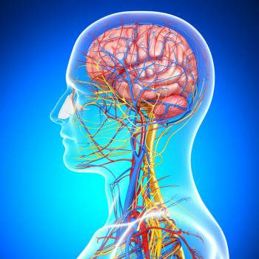

-DO NOT MARK THIS BOOKLET-

Multiple Choice: 15 marks

Short Answer: 25 marks

**TOTAL 40 MARKS**

1 The autonomic nervous system includes

1. the brain and spinal cord.
2. the sensory and motor nerves.
3. the cerebellum and cerebrum.
4. the sympathetic and parasympathetic nervous systems.

2 Put the following parts of a reflex arc in the correct order, beginning with the sensory receptor.

1. motor neuron

2. interneuron

3. effector

4. sensory neuron

5. sensory receptor

(a) 5, 1, 2, 3, 4

(b) 5, 3, 2, 4, 1

(c) 5, 4, 3, 2, 1

(d) 5, 4, 2, 1, 3

3 The brain part which regulates sleep, food intake and thirst is the:

(a) cerebrum.

(b) hypothalamus.

(c) medulla.

(d) midbrain.

4 Which one of the following is NOT a characteristic of a sensory neurone?

(a) its cell body is located in the dorsal root ganglion.

(b) it forms synapses with the connector neurone in the grey matter of the spinal cord.

(c) it carries nerve impulses from an effector.

(d) it carries nerve impulses towards the CNS.

5 Which of the following statements about the axon of a neurone is/are correct?

i. it is the longest part of the neurone.

ii. it transmits nerve impulses away from the cell body.

iii. it is wrapped by myelin sheath.

(a) ii only.

(b) i and iii only.

(c) ii and iii only.

(d) i, ii and iii.

**Questions 6 and 7 refer to the diagram below.**

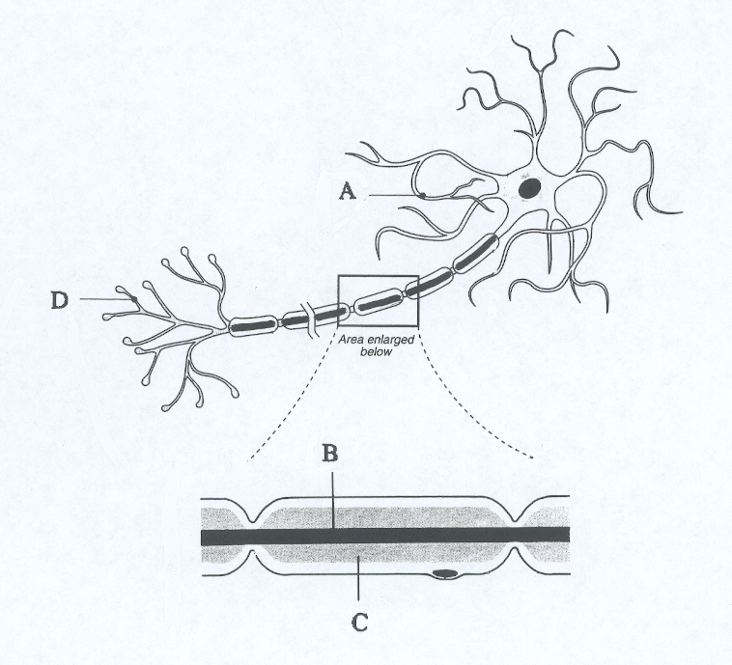

6. Which part of the structure shown above increases the speed of nerve impulse transmission?

1. A
2. B
3. C
4. D

7. Which one of the following statements about the neuron shown above is correct?

1. This neuron does not show evidence of a Schwan cell.
2. Structure B will produce the myelin sheath.
3. Structure D receives impulses from other neurons.

(d) Structure A transmits impulses to the cell body.

1. Which of the following is the correct path of sound transmission through the ear?
2. tympanum,ossicles,pinna,round window,cochlea
3. pinna,typanum,ossicles,oval window,cochlea
4. ossicles,pinna,typanum,cochlea,round window
5. pinna,ossicles,typanum,round window,cochlea

9 Which of the following separates the outer ear from the middle ear?

1. Cochlea
2. Three ear bones
3. Eardrum
4. Eustachian tube

10 Hearing loss affects many people. Sometimes, sound at either high or low frequencies, or both, cannot easily be detected. This is most likely due to damage of the:

(a) auditory ossicles.

(b) tympanic membrane.

(c) cochlea.

(d) oval window, although occasionally the round window also becomes damaged.

11 Which of the following structures of the ear is the first part to vibrate when sound waves enter the ear?

(a) Pinna.

(b) Incus.

(c) Oval window.

(d) Tympanic membrane.

12. Which of the following are needed to achieve a full sense of balance?

i. semicircular canals

ii. vision

iii. medulla oblongata

iv. cerebellum

(a) i and ii only.

(b) i and iii only.

(c) i, ii and iv only.

(d) i, ii, iii and iv.

13 Which of the following diagrams show how a sight condition can be corrected by a suitable lens?

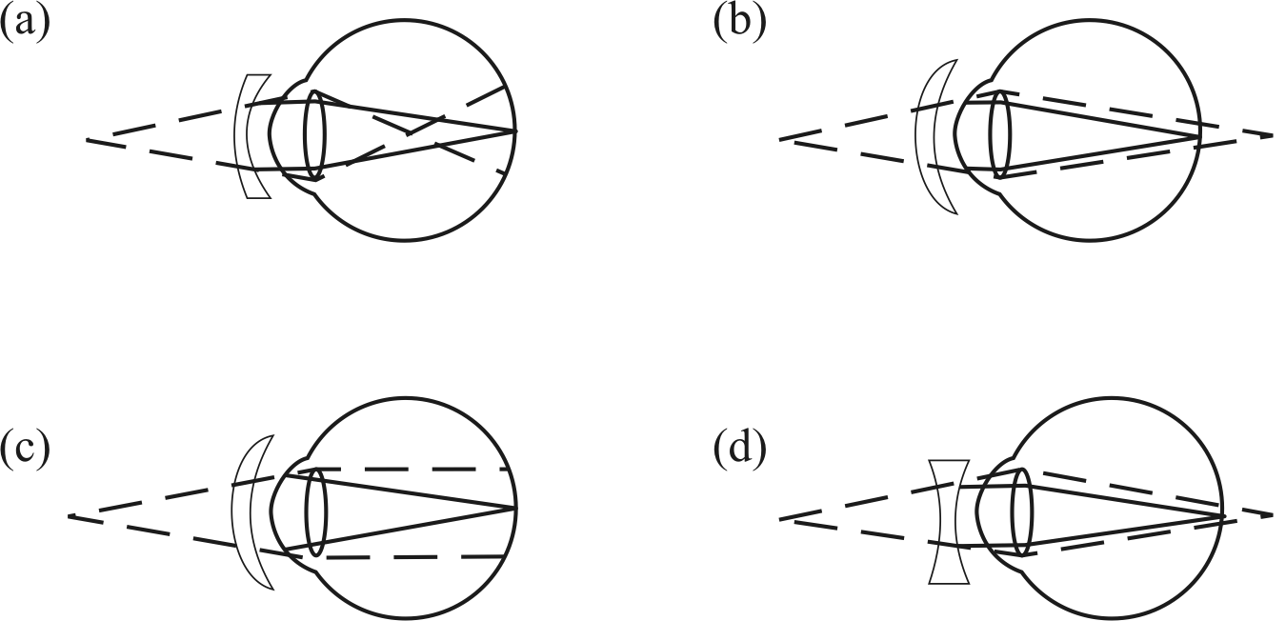

14 The heart rate can be increased by stimulating

(a) somatic nerves.

(b) cranial nerves.

(c) parasympathetic nerves.

(d) sympathetic nerves.

***Note:*** *The next questions refer to the diagram below.*

A

Modulator

C

D

Stimulus: Rise in body temperature

15. The diagram above represents a homeostatic loop model. In general terms A and C   
refer to

(a) receptor and negative feedback.

(b) receptor and effector.

(c) receptor and response.

(d) response and mode of transmission.

**PART B: Short Answer Section (25 marks)**

Study the cross-section of the human brain and answer the questions that follow.

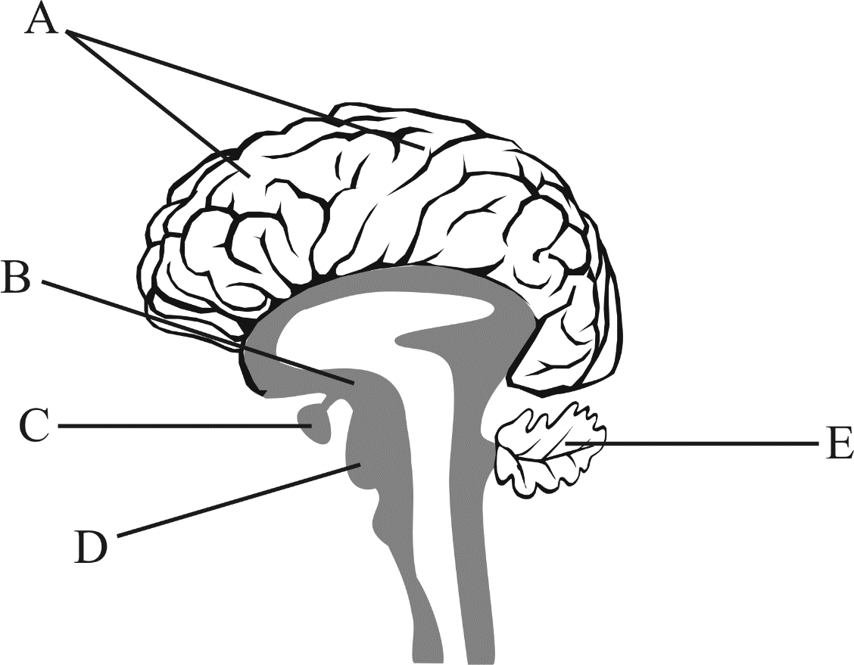

16 (a) Using your knowledge of the brain, identify the parts labelled below.

A ___________________________

B ___________________________

C ___________________________

D. ___________________________

E ____________________________

(b) Explain the function of the following: (4 marks)

i) E

____________________________________________________________________________________________________________________________________________________________________________________________________________________________________________________________________________________________________________

ii) C

____________________________________________________________________________________________________________________________________________________________________________________________________________________________________________________________________________________________________________

17(a) The following are descriptions or functions of structures found in the eye.

(5 marks)

A. stimulated by bright light and responsible for colour vision;

B. covers the external surface of the cornea and lines the inside of the eyelids;

C. round black hole through which light reaches the inside of the eye;

D. stimulated by dim light;

E. the white part of the eye;

F. produces the sharpest vision.

For each structure listed below, write the one letter best associated with the appropriate description or function.

(i) Sclera

(ii) Rods

(iii) Fovea

(iv) Cones

(v) Conjunctiva

.

**Figure 3**: Cross section of the human eye

A

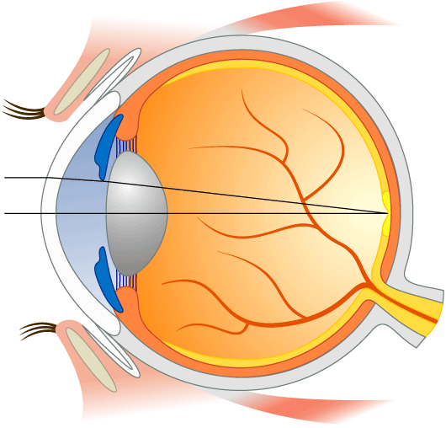

B

C

D

b. Label the parts of the eye indicated in the Figure 3. (4 marks)

A. _________________________________

B. _________________________________

C. _________________________________

D. _________________________________

**(Total 9 marks)**

**Question 18 (7 marks)**

(a) List, in order of impulse transmission, the neurons involved in a spinal reflex arc.

(1 mark)

_________________________________________________________________________________________________________________________________________________________________________________________________________________________________________________________________­­­­­­­­­­­­­­­­­­­­­­­­­_______________________________________________________________

________________________________________________________________________________________________________________________________________________________________________________________________________________________________________________________________________________________________________________________________

(b) Explain why conscious thought would be a disadvantage in a reflex behaviour.

(2 marks)

_________________________________________________________________________________________________________________________________________________________________________________________________________________________________________________________________­­­­­­­­­­­­­­­­­­­­­­­­­_______________________________________________________________

________________________________________________________________________________________________________________________________________________________________________________________________________________________________________________________________________________________________________________________________

________________________________________________________________________________________________________________________________________________________________________________________________________________________________________________________________________________________________________________________________________________________________________________________________________________

(c) In a reflex arc, as in all nerve pathways, an impulse travels in only one direction.

Explain why. (2 marks)

__________________________________________________________________________________________________________________________________________________________________________________________________________________________________________________________________­­­­­­­­­­­­­­­­­­­­­______________________________________________________________

________________________________________________________________________________________________________________________________________________________________________________________________________________________________________________________________________________________________________________________________

________________________________________________________________________________

(d) When a nerve impulse reaches the end of an axon, it cannot go any further as it

reaches a gap called a synapse. Explain how the impulse can continue on to the next

neuron.

(2 marks)

_________________________________________________________________________________________________________________________________________________________________________________________________________________________________________________________________­­­­­­­­­­­­­­­­­­­­­­­­­_______________________________________________________________

________________________________________________________________________________________________________________________________________________________________________________________________________________________________________________________________________________________________________________________________



**YEAR 12 GTHBY HUMAN BIOLOGY**

Task 5: Nervous Systems Test

SCORES:

MC: /15

SA: /25

TOTAL: /40

_______ %

**NAME:_____________________________**

**TEACHER:__________________________**

**DATE:______________________________**

**Section A: Multiple choice (15 Marks)**

Answer all questions by circling the most correct answer on the multiple choice answer sheet.

1. a b c d 13. a b c d

2. a b c d 14. a b c d

3. a b c d 15. a b c d

4. a b c d

5. a b c d

6. a b c d

7. a b c d

8. a b c d

9. a b c d

10. a b c d

11. a b c d

12. a b c d